PAYMENT IS DUE WHEN ORDER IS PLACED

Due to the many variables involved, the Seller disclaims any warranties of any kind on the trees and berries.

Orders will be taken UNTIL February 21, 2013 – with delivery in March.

To place an order, call 870-793-4164 Ext. 3 or visit us in our office at 490 E. College Street, Room 242 (second floor) Batesville Federal Bldg. (Post Office) OR mail in the tree order form along with your check payable to the Independence County Conservation District and mail to 490 E. College Street, Room 242, Batesville, AR 72501

ORDER FORM
Species | Quantity | Price Each | Total
TREES
Red Maple, 3-4’ | _________ | $4.50 | __________
White Dogwood, 3-4’ | _________ | $4.50 | __________
Eastern Redbud, 3-4’ | __________ | $4.50 | ___________
FRUIT
Early Elberta Peach 3-4’ | __________ | $8.50 | ___________
Jonathan Apple 3-4’ | __________ | $8.50 | ___________
Muscadine Grape Seedling 18-24” | __________ | $5.50 | ___________
SHRUB
Crapemyrtle Red, 2-3’ | __________ | $4.00 | __________
Crapemyrtle Pink, 2-3’ | __________ | $4.00 | ___________
Crapemyrtle White, 2-3’ | __________ | $4.00 | ___________
Crapemyrtle Purple, 2-3’ | __________ | $4.00 | ___________
Crapemyrtle peppermint, Semi Dwarf 18-24” | __________ | $3.50 | ____________
Forsythia Lynwood Gold, 2-3’ | __________ | $3.50 | ____________
BERRIES
Delite Blueberries 9-12” | __________ | $5.50 | ____________
Rabbiteye Blueberries, Climax 9-12” | __________ | $5.50 | ____________
#1 Plant Thornless Blackberries | __________ | $5.50 | ____________
TOTAL DUE |  |  | ____________
Name:________________________________Phone:(H)_______________(W)__________________(C)______________
Address: __________________________________________________________________________________________
CITY STATE ZIP
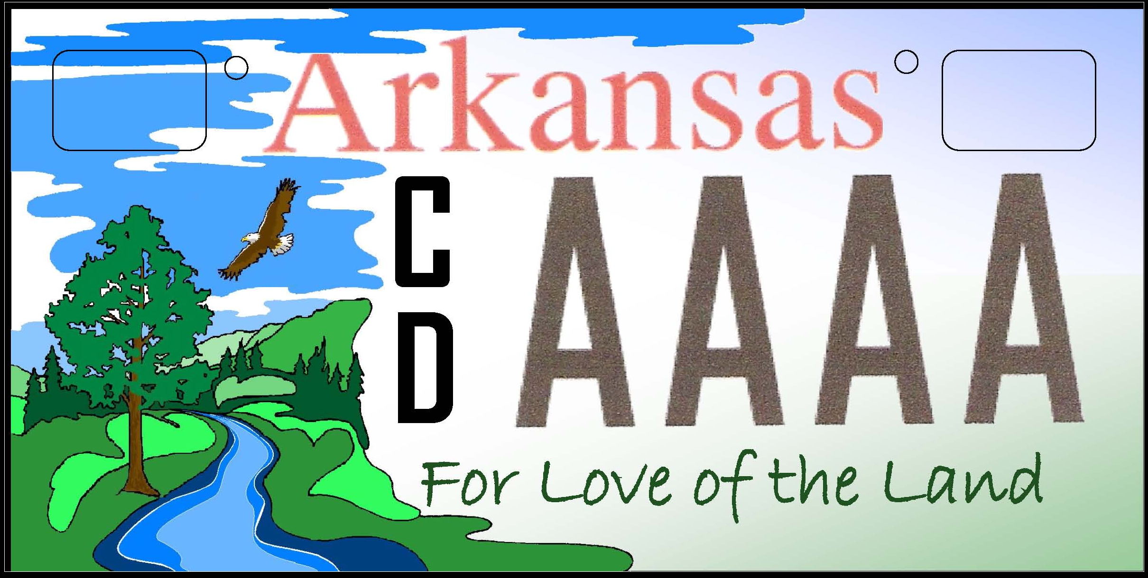 Conservation District License Plate
Here is a way to show your “Love for the Land”. Purchase this specialty license plate at your revenue department and support your local Conservation District.

